|  |
| --- |
| Liquid Robot |
| RATM Test Plan |
|  |

|  |
| --- |
| Kitman Yiu  2015/3/6 |

Content

[TESTPLAN IDENTIFIER 2](#_Toc413443229)

[INTROUDUCTION 2](#_Toc413443230)

[TEST ITEMS 3](#_Toc413443231)

[FEATURED TO BE TESTED 4](#_Toc413443232)

[FEATURED NOT BE TESTED 4](#_Toc413443233)

[APPROACH 5](#_Toc413443234)

[• Testing levels 5](#_Toc413443235)

[• Unit testing 5](#_Toc413443236)

[• Integration testing 5](#_Toc413443237)

[• Validation testing 5](#_Toc413443238)

[• Acceptance testing 5](#_Toc413443239)

[ITEM PASS/ FAIL CRITERIA 6](#_Toc413443240)

[• Unit Testing 6](#_Toc413443241)

[• Integration Testing 6](#_Toc413443242)

[• Validation Testing 6](#_Toc413443243)

[• Acceptance Testing 6](#_Toc413443244)

[Suspension Criteria and Resumption Requirements 7](#_Toc413443245)

[• Suspension Criteria 7](#_Toc413443246)

[• Resumption Requirement 7](#_Toc413443247)

[Test Deliverables 7](#_Toc413443248)

[• Test Log 7](#_Toc413443249)

[Test Tasks 8](#_Toc413443250)

[Environmental Needs 9](#_Toc413443251)

[• Hardware 9](#_Toc413443252)

[• Software 9](#_Toc413443253)

[• Communications 9](#_Toc413443254)

[Responsibilities 10](#_Toc413443255)

[Staffing and Training Needs 10](#_Toc413443256)

# C:\Users\Kitman\Google Drive\School\==CIT==\2015_Application Testing & Metrics\Assigment 2\Pictures\wowscrnshot101407130246ml3.jpg

# C:\Users\Kitman\Google Drive\School\==CIT==\2015_Application Testing & Metrics\Assigment 2\Pictures\q9i1i76os9cvzve8o0mg.png

From the above images which one do you think is more easier to find the information (eg: gun ) that you want ?

Of course as most of you will choice image2.

So how can the Image1 be design to allow people to find there thing more easily?

Answer is Information architecture. **Information architecture is how information are represent to the user.**

# 

# INTROUDUCTION

In this paper we are going to talk about Information architecture or IA and also ??. After that we are going to give an example that how information architecture can be applied to game development. The following image is the diagram that represent the connections between IA and ????

The following image a simply flow of current paper

# History of Information Architecture

Back to mid-1970s and Richard Saul Wurman’s famous address at the American Institute of Architecture conference of 1976, use of the term information together with the term architecture [[1](http://journalofia.org/volume3/issue2/03-resmini/#footnote1)] has been around for a little bit longer and in quite a few different settings. In an IBM research paper written in 1964, some 12 years before Wurman, and entitled “Architecture of the IBM System/360” (Amdahl et al 1964), architecture is defined as

*the conceptual structure and functional behavior, distinguishing the organization of data flows and controls, logical design, and physical implementation.*

It is not disputable that we are talking computer architectures here, disks and boxes and wires and hubs, but the way in which the term architecture is abstracted and conceptualized in connection with structure and behavior and not just physical layouts laid the basis for the subsequent extension of its use to other areas of computing [[2](http://journalofia.org/volume3/issue2/03-resmini/#footnote2)].

A few years later, in 1970, at the Xerox Palo Alto Research Center (PARC), a group of people specialized in information science was assembled and then given the charter to develop technology which could support the “architecture of information” (Pake 1985). This group was single-handedly responsible for a number of important contributions in what we would call today the field of human-computer interaction, including the first personal computer with a user-friendly interface, laser printing, and the first WYSIWYG text editor. As Marti Hearst, now a professor at the University of California Berkeley, recalls,

*(p)erhaps because of the social nature of information creation and use, much of the technical research at PARC has emphasized the human-computer interaction and social aspects of computing.*

Weitzman (1995) supports this notion that the modern inception of the term originally came from Xerox Labs [[3](http://journalofia.org/volume3/issue2/03-resmini/#footnote3)]. Quoting Smith and Alexander (1988), Weitzman maintains that

Xerox was among the first corporations to address this notion of information structure and use the “elegant and inspiring phraseology, the architecture of information” to define its new corporate mission.

This high-level framing, the necessity for a broader vision, remained one of the core concepts for those who wrote about information architecture up to the mid-1980s, as much as this joining of specialists in information science and in user-focused development (Ronda León 2008), a trait that will be somehow brought to greater visibility and results by the first wave of modern information architects in the 1990s.

From the mid-1980s, information architecture seemingly went through a dormant period, during which the idea of information architecture as both the design of complex or dynamically changing information seemed to be lost to a view much more akin to that of information systems. Articles written in those years mostly refer to information architecture as a tool for the design and creation of computer infrastructures and data layers, with a larger emphasis on the organizational and business aspects of the information networks (Morrogh 2003).

Curiously enough, much of the design deliverables we associate with information architecture today are a product of this period: blueprints, requirements, information categories, guidelines on the underlying business processes, global corporate needs, they all make their way into information architecture-related territory in the 1980s (Brancheau & Wetherbe 1986). They will be incorporated once and for all in the information architect’s toolkit by the wave of the late 1990s lead by Rosenfeld and Morville.

An image is represent below of the history of IA:

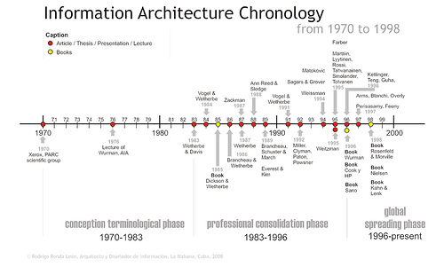

# Definition

The definition of IA

*Information architecture* has somewhat different meanings in different branches of [IS](http://en.wikipedia.org/wiki/Information_system) or [IT](http://en.wikipedia.org/wiki/Information_technology):

1. The structural design of shared information environments.[[4]](http://en.wikipedia.org/wiki/Information_architecture#cite_note-FOOTNOTERosenfeldMorville1998-4)[[*page needed*](http://en.wikipedia.org/wiki/Wikipedia:Citing_sources)]
2. The art and science of organizing and labeling web sites, intranets, online communities, and software to support [findability](http://en.wikipedia.org/wiki/Findability) and [usability](http://en.wikipedia.org/wiki/Usability).[[1]](http://en.wikipedia.org/wiki/Information_architecture#cite_note-What-1)[[4]](http://en.wikipedia.org/wiki/Information_architecture#cite_note-FOOTNOTERosenfeldMorville1998-4)[[*page needed*](http://en.wikipedia.org/wiki/Wikipedia:Citing_sources)]
3. An emerging [community of practice](http://en.wikipedia.org/wiki/Community_of_practice) focused on bringing principles of design and architecture to the digital landscape.[[4]](http://en.wikipedia.org/wiki/Information_architecture#cite_note-FOOTNOTERosenfeldMorville1998-4)[[*page needed*](http://en.wikipedia.org/wiki/Wikipedia:Citing_sources)][[5]](http://en.wikipedia.org/wiki/Information_architecture#cite_note-5)
4. The combination of organization, labeling, search and navigation systems within websites and intranets.[[4]](http://en.wikipedia.org/wiki/Information_architecture#cite_note-FOOTNOTERosenfeldMorville1998-4)[[*page needed*](http://en.wikipedia.org/wiki/Wikipedia:Citing_sources)]
5. Extracting required parameters/data of Engineering Designs in the process of creating a knowledge-base linking different systems and standards.

The difficulty in establishing a common definition for "information architecture" arises partly from the term's existence in multiple fields. In the field of [systems design](http://en.wikipedia.org/wiki/Systems_design), for example, information architecture is a component of[enterprise architecture](http://en.wikipedia.org/wiki/Enterprise_architecture) that deals with the information component when describing the structure of an enterprise.While the definition of information architecture is relatively well-established in the field of systems design, it is much more debatable within the context of online information systems (i.e., websites). Andrew Dillon refers to the latter as the "big IA-little IA debate".[[6]](http://en.wikipedia.org/wiki/Information_architecture#cite_note-6) In the little IA view, information architecture is essentially the application of information science to web design which considers, for example, issues of classification and information retrieval. In the big IA view, information architecture involves more than just the organization of a website; it also factors in [user experience](http://en.wikipedia.org/wiki/User_experience), thereby considering [usability](http://en.wikipedia.org/wiki/Usability) issues of [information design](http://en.wikipedia.org/wiki/Information_design).

The first thing …..

Lou Rosenfeld and Peter Morville in their book, Information Architecture for the World Wide Web, note that the main components of IA:

* **Organization**[**Schemes**](http://www.usability.gov/how-to-and-tools/methods/organization-schemes.html)**and**[**Structures**](http://www.usability.gov/how-to-and-tools/methods/organization-structures.html): How you categorize and structure information
* **Labeling Systems**: How you represent information
* **Navigation Systems**: How users browse or move through information
* **Search Systems**: How users look for information

In order to create these systems of information, you need to understand the interdependent nature of users, content, and context.  Rosenfeld and Morville referred to this as the “information ecology” and visualized it as a venn diagram.  Each circle refers to:

* **Context**: business goals, funding, politics, culture, technology, resources, constraints
* **Content**: content objectives, document and data types, volume, existing structure, governance and ownership
* **Users**: audience, tasks, needs, information-seeking behavior, experience

**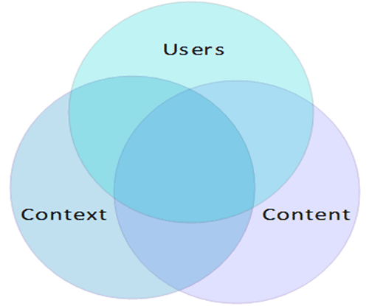**

This concept can also be include in game development, the reason is listed below:

Starting from up to down

1. Use for what and then what does the end user need and then how will the information be connected to each other

信息架构是VI设计之前一项非常重要的工作，它直接关系到用户的使用感受，在信息架构工作中我们要有重点，有条理的对内容  
进行分析：  
  
一  用户需求、用户视觉：用用户的眼光来分析，用户的视觉、用户对内容的需要、用户的心理等等都是可参考的重要信息。  
  
二  内容划分、模块设置：根据自身内容设置出信息模块，将这些信息模块展现到页面上去。  
  
三  导航:重要度在页面里可能是９９％　也可能是１％ 导航决定了整个网站的结构。  
  
四  内容展现形式:图、文是页面排版的两大要素，颜色、边框、形状是辅助元素，这些因素组成了页面主体。  
  
五  时间，任何的信息架构都很难一次性做的很完美，必须不断调整细节，时间和耐心是好的信息架构必须具备的条件。  
  
六  形象化、专业性的思维，信息架构是落地的工作，不是虚无飘渺的战略，也不是具体的算法，专业性要求架构者具备良好的  
专业素质，能将专业和具体事务结合起来，将专业知识和技能应用到信息架构里去。  
  
七  分析、演讲能力，将自己的成果展示给大家，从自己的思路入手，引导其他人不跑偏，不在无关痛痒的细节上纠缠。  
  
八  VI/UE：在架构完后的设计过程中中，架构者一样也得参与进去，和设计师一起将信息架构的本质：“展现”做好。

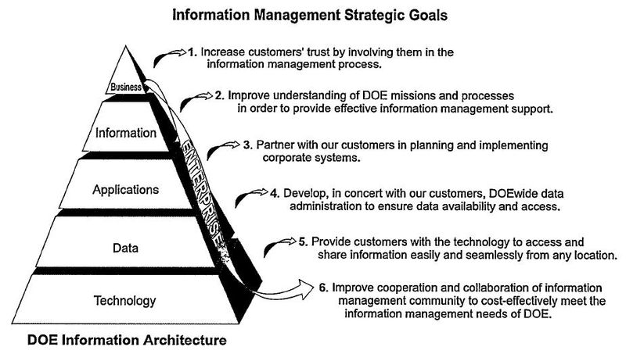

# Examples

Assuming we are going to make portfolio webpage

The following things can be included that related to IA:

1. The pages that you design
2. What things are in the pages are how are they going to been see by user

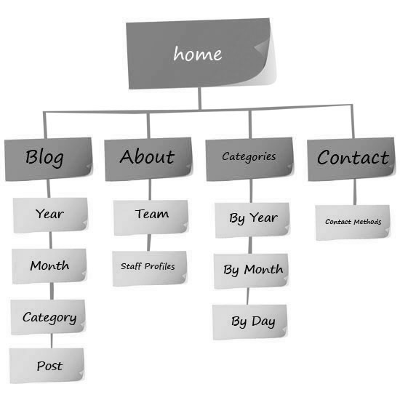

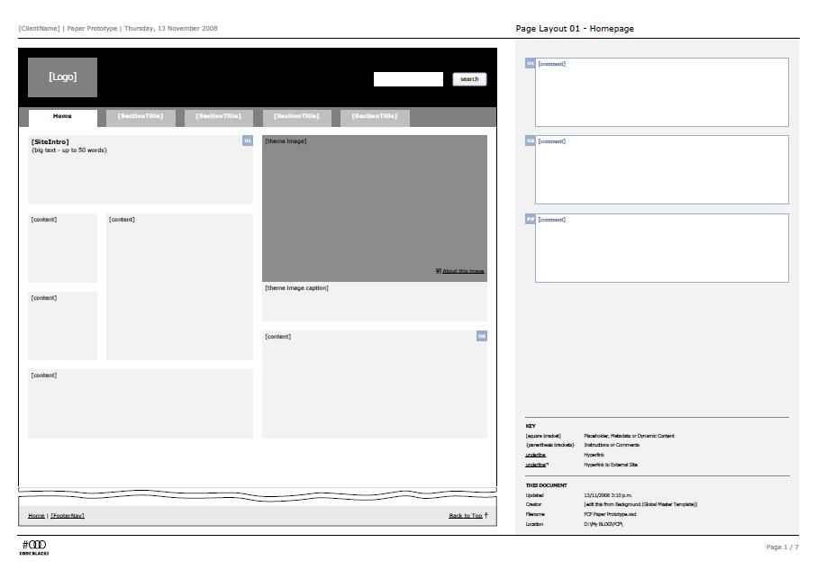

# Web usability principles

Web: Same meaning as www

Usability: Usability is a **quality attribute**that assesses how easy user interfaces are to use. The word "usability" also refers to methods for improving ease-of-use during the design process

Principle: A **principle** is a law or rule that has to be, or usually is to be followed

Web usability principles means: Some rules that allow people to

* **Learnability**: How easy is it for users to accomplish basic tasks the first time they encounter the design?
* **Efficiency**: Once users have learned the design, how quickly can they find there information?
* **Memorability**: When users return to the design after a period of not using it, how easily can they reestablish proficiency?
* **Errors**: How many errors do users make, how severe are these errors, and how easily can they recover from the errors?
* **Satisfaction**: How pleasant is it to use the design?

Jakob Nielsen's 10 general principles for interaction design. They are called "heuristics" because they are broad rules of thumb and not specific usability guidelines.

Jakob Nielsen’s:

Jakob Nielsen, Ph.D., is a User Advocate and principal of the Nielsen Norman Group which he co-founded with Dr. Donald A. Norman (former VP of research at Apple Computer). Dr. Nielsen established the "discount usability engineering" movement for fast and cheap improvements of user interfaces and has invented several usability methods, including heuristic evaluation. He holds 79 United States patents, mainly on ways of making the Internet easier to use.

**Visibility of system status**

The system should always keep users informed about what is going on, through appropriate feedback within reasonable time.

**Match between system and the real world**

The system should speak the users' language, with words, phrases and concepts familiar to the user, rather than system-oriented terms. Follow real-world conventions, making information appear in a natural and logical order.

**User control and freedom**

Users often choose system functions by mistake and will need a clearly marked "emergency exit" to leave the unwanted state without having to go through an extended dialogue. Support undo and redo.

**Consistency and standards**

Users should not have to wonder whether different words, situations, or actions mean the same thing. Follow platform conventions.

**Error prevention**

Even better than good error messages is a careful design which prevents a problem from occurring in the first place. Either eliminate error-prone conditions or check for them and present users with a confirmation option before they commit to the action.

**Recognition rather than recall**

Minimize the user's memory load by making objects, actions, and options visible. The user should not have to remember information from one part of the dialogue to another. Instructions for use of the system should be visible or easily retrievable whenever appropriate.  
(Read full article on [recognition vs. recall in UX](http://www.nngroup.com/articles/recognition-and-recall/).)

**Flexibility and efficiency of use**

Accelerators -- unseen by the novice user -- may often speed up the interaction for the expert user such that the system can cater to both inexperienced and experienced users. Allow users to tailor frequent actions.

**Aesthetic and minimalist design**

Dialogues should not contain information which is irrelevant or rarely needed. Every extra unit of information in a dialogue competes with the relevant units of information and diminishes their relative visibility.

**Help users recognize, diagnose, and recover from errors**

Error messages should be expressed in plain language (no codes), precisely indicate the problem, and constructively suggest a solution.

**Help and documentation**

Even though it is better if the system can be used without documentation, it may be necessary to provide help and documentation. Any such information should be easy to search, focused on the user's task, list concrete steps to be carried out, and not be too large.

# Usability testing

To able to tell the result of successful we can do a test , **Usability testing** is a technique used in [user-centered](http://en.wikipedia.org/wiki/User-centered_design) [interaction design](http://en.wikipedia.org/wiki/Interaction_design) to evaluate a product by testing it on users

The able to achive Usability testing there are three methods

### Hallway testing[[edit](http://en.wikipedia.org/w/index.php?title=Usability_testing&action=edit&section=3)]

**Hallway testing** is a general method of usability testing. Rather than using an in-house, trained group of testers, five to six [randomly](http://en.wikipedia.org/wiki/Random)-selected people are brought in to test the product, or service. The name of the technique refers to the fact that the testers should be random people who pass by in the hallway.[[3]](http://en.wikipedia.org/wiki/Usability_testing#cite_note-useit-3)

Hallway testing is particularly effective in the early stages of a new design when the designers are looking for "brick walls," problems so serious that users simply cannot advance. Anyone of normal intelligence other than designers and engineers can be used at this point. (Both designers and engineers immediately turn from being test subjects into being "expert reviewers." They are often too close to the project, so they already know how to accomplish the task, thereby missing ambiguities and false paths.)

### Remote Usability Testing[[edit](http://en.wikipedia.org/w/index.php?title=Usability_testing&action=edit&section=4)]

In a scenario where usability evaluators, developers and prospective users are located in different countries and time zones, conducting a traditional lab usability evaluation creates challenges both from the cost and logistical perspectives. These concerns led to research on remote usability evaluation, with the user and the evaluators separated over space and time. Remote testing, which facilitates evaluations being done in the context of the user’s other tasks and technology can be either synchronous or asynchronous. Synchronous usability testing methodologies involve video conferencing or employ remote application sharing tools such as WebEx. The former involves real time one-on-one communication between the evaluator and the user, while the latter involves the evaluator and user working separately.[[4]](http://en.wikipedia.org/wiki/Usability_testing#cite_note-4)

Asynchronous methodologies include automatic collection of user’s click streams, user logs of critical incidents that occur while interacting with the application and subjective feedback on the interface by users.[[5]](http://en.wikipedia.org/wiki/Usability_testing#cite_note-5) Similar to an in-lab study, an asynchronous remote usability test is task-based and the platforms allow you to capture clicks and task times. Hence, for many large companies this allows you to understand the WHY behind the visitors' intents when visiting a website or mobile site. Additionally, this style of user testing also provides an opportunity to segment feedback by demographic, attitudinal and behavioural type. The tests are carried out in the user’s own environment (rather than labs) helping further simulate real-life scenario testing. This approach also provides a vehicle to easily solicit feedback from users in remote areas quickly and with lower organisational overheads.

Numerous tools are available to address the needs of both these approaches. WebEx and Go-to-meeting are the most commonly used technologies to conduct a synchronous remote usability test.[[6]](http://en.wikipedia.org/wiki/Usability_testing#cite_note-6) However, synchronous remote testing may lack the immediacy and sense of “presence” desired to support a collaborative testing process. Moreover, managing inter-personal dynamics across cultural and linguistic barriers may require approaches sensitive to the cultures involved. Other disadvantages include having reduced control over the testing environment and the distractions and interruptions experienced by the participants’ in their native environment.[[7]](http://en.wikipedia.org/wiki/Usability_testing#cite_note-7) One of the newer methods developed for conducting a synchronous remote usability test is by using virtual worlds.[[8]](http://en.wikipedia.org/wiki/Usability_testing#cite_note-8) In recent years, conducting usability testering asynchronously has also become prevalent and allows testers to provide their feedback at their free time and in their own comfort at home. Many tools are available online that facilitate this process including UserTesting, UXArmy, Optimizely, Usabilla, UserZoom etc.

### Expert review[[edit](http://en.wikipedia.org/w/index.php?title=Usability_testing&action=edit&section=5)]

Expert review is another general method of usability testing. As the name suggests, this method relies on bringing in experts with experience in the field (possibly from companies that specialize in usability testing) to evaluate the usability of a product.

A [Heuristic evaluation](http://en.wikipedia.org/wiki/Heuristic_evaluation) or **Usability Audit** is an evaluation of an interface by one or more Human Factors experts. Evaluators measure the usability, efficiency, and effectiveness of the interface based on usability principles, such as the 10 usability heuristics originally defined by Jakob Nielsen in 1994.[[9]](http://en.wikipedia.org/wiki/Usability_testing#cite_note-9)

Nielsen’s Usability Heuristics, which have continued to evolve in response to user research and new devices, include:

* Visibility of System Status
* Match Between System and the Real World
* User Control and Freedom
* Consistency and Standards
* Error Prevention
* Recognition Rather Than Recall
* Flexibility and Efficiency of Use
* Aesthetic and Minimalist Design
* Help Users Recognize, Diagnose, and Recover from Errors
* Help and Documentation

### Automated expert review

Similar to expert reviews, **automated expert reviews** provide usability testing but through the use of programs given rules for good design and heuristics. Though an automated review might not provide as much detail and insight as reviews from people, they can be finished more quickly and consistently. The idea of creating surrogate users for usability testing is an ambitious direction for the Artificial Intelligence community.

### A/B testing[[edit](http://en.wikipedia.org/w/index.php?title=Usability_testing&action=edit&section=7)]

*Main article:*[*A/B testing*](http://en.wikipedia.org/wiki/A/B_testing)

In web development and marketing, A/B testing or split testing is an experimental approach to web design (especially user experience design), which aims to identify changes to web pages that increase or maximize an outcome of interest (e.g., click-through rate for a banner advertisement). As the name implies, two versions (A and B) are compared, which are identical except for one variation that might impact a user's behavior. Version A might be the one currently used, while version B is modified in some respect. For instance, on an e-commerce website the purchase funnel is typically a good candidate for A/B testing, as even marginal improvements in drop-off rates can represent a significant gain in sales. Significant improvements can be seen through testing elements like copy text, layouts, images and colors.

Multivariate testing or bucket testing is similar to A/B testing but tests more than two versions at the same time.

Also how many people should be testing?

In the early 1990s, [Jakob Nielsen](http://en.wikipedia.org/wiki/Jakob_Nielsen_(usability_consultant)), at that time a researcher at [Sun Microsystems](http://en.wikipedia.org/wiki/Sun_Microsystems), popularized the concept of using numerous small usability tests—typically with only five test subjects each—at various stages of the development process. His argument is that, once it is found that two or three people are totally confused by the home page, little is gained by watching more people suffer through the same flawed design. "Elaborate usability tests are a waste of resources. The best results come from testing no more than five users and running as many small tests as you can afford."[[3]](http://en.wikipedia.org/wiki/Usability_testing#cite_note-useit-3) Nielsen subsequently published his research and coined the term [heuristic evaluation](http://en.wikipedia.org/wiki/Heuristic_evaluation).

The claim of "Five users is enough" was later described by a mathematical model[[10]](http://en.wikipedia.org/wiki/Usability_testing#cite_note-10) which states for the proportion of uncovered problems U

After the looking your website.

The connection between Information Articela and web usability principles

The first thing we should do before creating the game is clealy the detentions of IA in game developer:

IA

The reason is listed below:

The following rules / ??? can be apply to game development:

The reason will be given by examples when creating the game.

So for now assume we are making a 2d game showed by the following image:

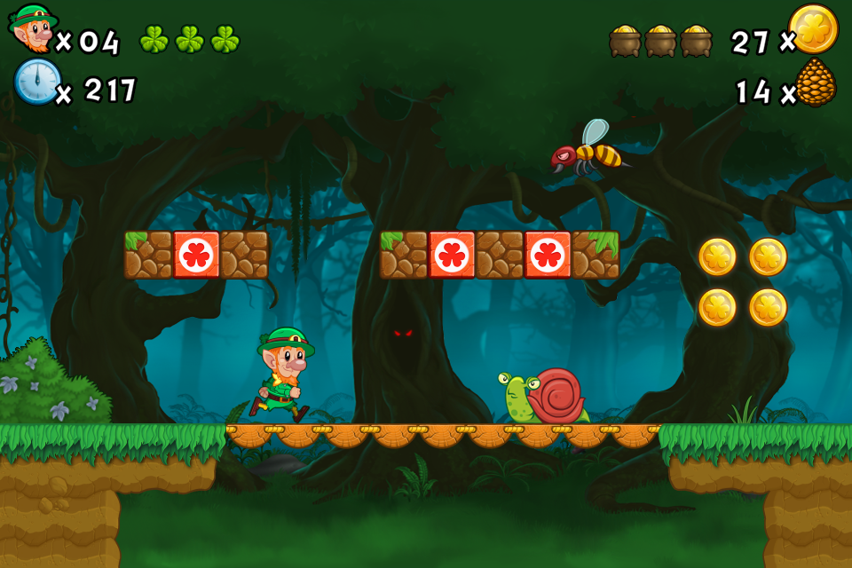

Which the player will go from the start to the end by avoiding or killing enemies and collecting coins, this is the video link of this game:

The process of making a design a good design can be apply

Less word , more image

Images can be apply to these following design

The able to reach the goal of ??? we can

The princele are

To ensure the princle can be achive we can …..

**Reference**

(A Brief History of Information Architecture) http://journalofia.org/volume3/issue2/03-resmini/

<http://eleganthack.com/towards-a-new-information-architecture/>

(如何做信息架构设计)<http://www.slideshare.net/iambacchus/ss-1801047>

Defintion of Usibality <http://baike.baidu.com/view/1436.htm>

Introduction to Usability:http://www.nngroup.com/articles/usability-101-introduction-to-usability/

<http://www.zcool.com.cn/article/ZMTA4NDky.html>

<http://www.jianshu.com/p/a45e4ad68e20>

<http://en.wikipedia.org/wiki/Usability_testing>

<http://baike.baidu.com/view/2325591.htm>

<http://blog.jobbole.com/62067/>